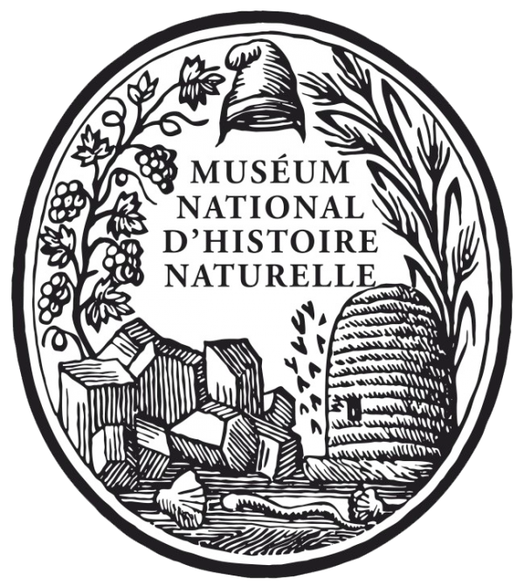

MNHN

Internship Report : Asteroids
By Irina Delamare, February 2018
Abstract :
I have been taking pictures of asteroids from Antarctica for Doctor Marc Eleaume. They were found by The Collaborative East Antarctic Marine Census (CEAMARC) campaign and identified by Doctor Christopher Mah. They are stored at the National Museum of Natural History (MNHN) of Paris in the collections not shown to the public. Doctor Marc Eleaume and his colleagues are doing an Atlas of all the marine invertebrates discovered by CEAMARC’s campaign. This document is the report of my internship.

Introduction :
I am in Terminale scientifique and the mechanism of evolution is fascinating me. I always wanted to become a researcher. I attend many conferences in biology and one day I was lucky to listen to Doctor’s Marc Eleaume lecture about crinoids. I know a few things about vertebrates but I knew nothing about invertebrates at that time. I figured it would be a great idea to do an internship with the curator of echinoderms and learn more about this phylum. I decided to go ask him an internship. He accepted and we planified the dates. I believe that I am really lucky to have met Doctor Eleaume and to have done an internship with him. So I gratefully thanks Doctor Marc Eleaume that made this internship possible.

Report :
From February 19th to February 23rd 2018, I was doing an internship at the National Museum of Natural History of Paris managed by Doctor Marc Eleaume.
I was keen on doing it because I wanted to become more familiar with the research world. My internship director is the curator of echinoderms of this Museum, Doctor Marc Eleaume. He welcomed me and made me discover his work.
I have met Doctor Eleaume at one of his conferences organised for the association “Les amis du musée“ as a thanks for donating to his campaigns.
My job during my internship was to take pictures of asteroids. Those pictures will be used for an atlas who make a census of all invertebrate of Antarctica.
I was taking pictures three floors underground under the “Grande Galerie de l'évolution“. This basement was built during the presidency of François Mitterand. All collections are kept into compactus in this basement. Compactus are like huge compact cupboards with a huge amount of specimens kept in. I was lucky enough to visit a few of them.
I saw a lot of different marine invertebrates. The museum even possesses some holotypes.
A holotype is a specimen that represent a species. Paratype design the additional specimen originally found with the holotype. Neotype is a paratype designed to be the new holotype when the original holotype is destroyed or armed. Syntype are a whole of specimens designed to all represent the species.
We enter the basement by a small old metallic door. Behind this gate we discover a long corridor with many security doors and fire doors. We get down the stairs to the last floor where marine invertebrates and birds are kept. Marc Eleaume is the curator of echinoderms, that mean that he is in charge of echinoderm collection.
He is a category A civil servant.
On my first day Marie teach me how to take good pictures of specimens. The asteroids we were using were kept in sealed jars in ethanol. To manipulate those specimens I needed plastic gloves, white overall and plastic glasses. Then I used metallic clamp to get the specimens out of their plastic bags.
Each specimen is associated with an identification number and is kept into his own plastic bag. “MNHN_IE_2009_ 3792” is an example of an identification number. With every specimens we also find the localisation of where he was found, the campagne who found it and the identification.
Every sample I pictured where from Antarctica. They were found by CEAMARC campaign and were identified by an American specialist of sea stars, Christopher L. Mah.
To identify the species of a specimen scientists use identification key.
Identification keys are a list of characteristics that defines a species among the others.
Biologists group organisms with different ranks. First, we have the phylum, then the class, the order, the family, the genus, and finally the species. A specimen name is composed by the genus and the species.
When we are classifying creatures, we are looking for homologous features that let think that a common ancestor had existed.
Class name always have the termination -ea and family name always have the termination -ae.
CEAMARC was a multinational contribution involving scientists and students from several nations using three ships from Australia, Japan and France surveying the one area.
Scientists decided to make an Atlas encountering all marine invertebrate of the area. To do so, each expert of a class needs to identify the species of this class.
For example, echinodermata is a phylum. They are five class of living echinoderms : asteroidea, ophiuroidea, echinoidea, holothuroidea and crinoidea.
Dr Marc Eleaume is an expert of crinoids. Crinoids are a sister group of all the other echinoderms. Quoting Wikipedia, a sister group is a phylogenetic term denoting the closest relatives of another given unit in an evolutionary tree.
We were taking pictures of asteroids because the experts of asteroidea, Christopher Mah, who identify each specimen, couldn’t take pictures of the samples who were in Paris. So Dr Eleaume decided to do the picture for him.
Asteroidea is close to ophiuroidea. They both have arms, a mouth pointing in the opposite direction of the anus, podia … , but one of the main differences is that the asteroids keep their organs in all their body. Ophiuroidea keep their organs only in the central region, not in the arms. Another difference is the podia, asteroids can’t retract their podia, ophiuroidea can. They can both regenerate when they lose a limbs.
What allows echinoderms to live in such cold climate is antifreeze proteins.
Asteroidea move their podia with sea water. Madreporit let the sea water in, this allowed the liquid to circulate in the asteroids arms and let the podia move.
I had to take three types of pictures for each specimen. The first picture I took of a specimen was the aboral side of the asteroid and all the papers that come with it (identification, localisation, campagne number and identification number).
The second type of picture was the aboral side. I tried to catch most of the details to allowed scientist who will look at the picture to study the specimen. To help the camera focus on all the details of a three-dimensional object, I did stacking. This method consists of taking several pictures of the same thing with different focuses. We use a software that stack all the images together. We obtain a single picture with all the details.
The third type of picture was the oral side. The oral side is the one with the mouth. The aboral side is the other one. We can find on the oral side the mouth, the ambulacre and the podia. I was using stacking method too.
The camera I was using was set on a stable device that didn't let her move. I was able to move the camera up and down to zoom and adjust the focus.
I have noticed that some asteroids have skin, other have plate and other have pike.
On the morning of my first day, I have learned how to take good pictures.
On the afternoon, the room where Dr Eleaume and I were working had a power failure so we couldn’t finish our job. So I visited the compactus. After that, we went outside. He was called by a colleague so we moved in another building. I was lucky enough to see a PCR machine (Polymerase Chain Reaction). I kept taking pictures the rest of the week.
We eventually managed to take pictures of all species of asteroids found in Antarctica. We took pictures of different asteroids of the same species. At the end, we have made nearly 1 000 pictures.
They found 991 asteroids in Antarctica from the seventh order of asteroidea : Brisingida, Forcipulatida, Spinulosida, Notomyotida, Paxillosida,Valvatida and Velatida.

Conclusion :
This internship allowed me to exchange with talented researchers and to learn about their work. I discovered this incredible place under “La Grande Galerie de l’Evolution” that keeps many of the collections of the MNHN in jars or compactus. I met a few people working at the museum as civil servants, or with a CDD or a CDI. It gave me an idea of which kind of work I could possibly do in the future.
I really enjoyed this internship and I want to learn more about echinoderms, taxonomy and phylogeny. This internship reassures me that biology is what I’d like to study.
I hope to find other opportunities to work with scientific organisations in near future.

